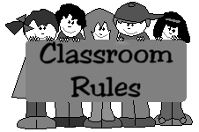
Anfrísia Santiago School

Class Rules Set 1
Always show respect for everyone in the class. Treat people the way you want to be treated.
- Don't talk when someone else is talking. Wait your turn!
- Come to class with all needed materials.
- When in doubt, always ask questions!
- Through attempt a question or problem before asking a question.

Class Rules Set #2
- Students will be on time, in their seat, and ready to go when the bell rings.
- Students will bring all needed materials to class.
- No food or drink in the classroom. This includes gum, candy, and water.
- All electronic device, unless medical, are forbidden. All electronic watches which emit loud alarms must be turned off.
- Students will also obey all district and school rules.

Class Rules Set #3
- Bring all your materials ( including homework ) with you every day.
- Come to class regularly and not be tardy.
- Sharpen your pencil before the tardy bell rings.
- Use the restroom between classes or during lunch. Please do not ask unless it is an emergency.
- Do not talk when the teacher is talking.
- Do not chew gum in class.
- Do not bring drinks to class.
- Be respectful to teacher and to one another.
- Have a positive attiude.

Class Rules Set #4
- Be in the classroom and seated by bell, each day. Those not in their seats at the start of class time will be counted tardy. Tardies will be handled according to school policy.
- No one will be allowed to leave the classroom without a pass from a staff member.
- Have locker and restroom needs taken care of before coming to class.
- Hats shall not be worn during class. Please remove hats upon entering the classroom.
- Be courteous! Do not talk while the teacher or another student is presenting material.
- Respect other people's feelings!
- Follow directions the first time they are given.
- Stay on task!
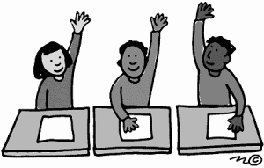
Class Rules Set #5
- Arrive on time.
- Raise your hand before speaking.
- Listen to others and participate in class discussions.
- Use the pencil sharpener during noninstructional time.
- Stay on task.
- Do your assignments.
- Bring materials and have them ready.
- Listen to directions.
- Cooperate with your group.
- Pick up after yourself.
- Leave other people's materials alone.
- Do not interrupt other students' learning.
- Keep hands, feet and objects to yourself.
- Keep your hands clean and take care of personal hygiene in the rest room during breaks.
- No vandalism. Don't write or carve on your desk or school property.
- Treat computers with care.

Class Rules Set #6
- One person at a time leaves the room with the hall pass.
- Clean your work station appropriately.
- Absolutely no food, drink, gum, or candy permitted.
- Do not come to class late without a hallpass.
- Be organized and prepared for class.

Class Rules Set #7
- Come to class prepared to learn. (Pencils sharpened, pen, paper, and notebooks)
- Respect all property. (School property, personal property, and other's property)
- Respect all ideas given in class and do not criticize anybody's ideas or thoughts.
- Do your very best!

