Take Me to the Ball Game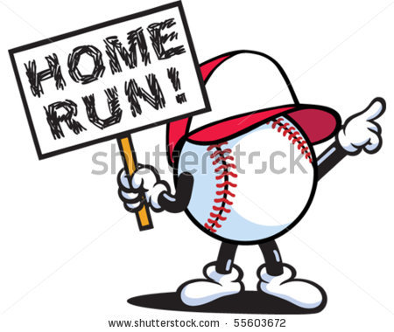
A: Can we go to the baseball game?
B: Of course.
A: I love baseball.
B: So do I.
A: I love to eat the peanuts.
B: I love to eat the hot dogs.
A: I hope we’ll see a home run.
B: I hope we’ll catch a foul ball.
A: Bring a jacket.
B: Yes. It gets a little cool at night.
A: Bring a glove to catch a foul ball.
B: No. I’ll just use my cap to catch a foul ball.

LISTEN!
http://www.eslfast.com/easydialogs/ec/sports01.htm

