 Irregular Past Verbs
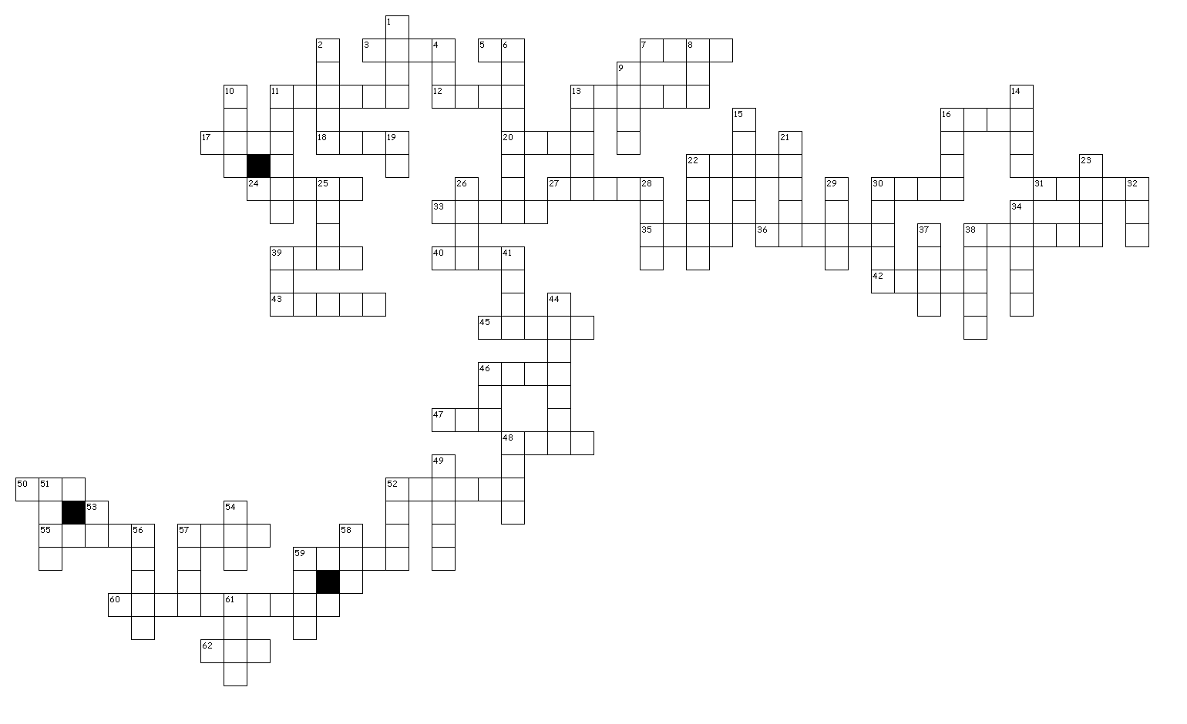

Across
3. - hid - hidden, hid
5. - did - done
7. - fell - fallen
11. - froze - frozen
12. - took - taken
13. - chose - chosen
16. - had - had
17. - wore - worn
18. - rang - rung
20. - cost - cost
22. - stole - stolen
24. - fought - fought
27. - shot - shot
30. - bent - bent
31. - crept - crept
33. - slept - slept
35. - lent - lent
36. - became - become
38. - spread - spread
39. - bit - bitten
40. - swam - swum
42. - drove - driven
43. - thought - thought
45. - stood - stood
46. - gave - given
47. - sat - sat
48. - knew - known
50. - flew - flown
52. - struck - struck
55. - spent - spent
57. - meant - meant
59. - swung - swung
60. - understood - understood
62. - put - put

Down
1. - rose - risen
2. - swore - sworn
4. - ate - eaten
6. - overcame - overcome
8. - lay - lain
9. - came - come
10. - felt - felt
11. - forbade - forbidden
13. - caught - caught
14. - led - led
15. - swept - swept
16. - held - held
19. - went - gone
21. - slid - slid
22. - shone - shone
23. - fed - fed
25. - hurt - hurt
26. - blew - blown
28. - told - told
29. - grew - grown
30. - bred - bred
32. - paid - paid
34. - brought - brought
37. - quit - quit
38. - spoke - spoken
39. - bet - bet
41. - met - met
44. - underwent - undergone
46. - got - gotten, got
48. - kept - kept
49. - broke - broken
51. - lost - lost
52. - sang - sung
53. - was, were - been
54. - laid - laid
56. - drank - drunk
57. - made - made
58. - bid - bid
59. - sent - sent
61. - shut - shut

