I Love Baseball
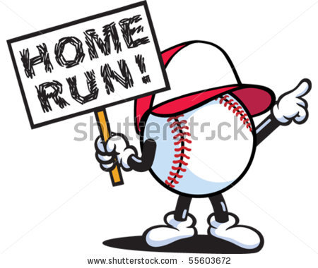

A: Baseball is fun.
B: I like to hit the ball.
A: I like to run around the bases.
B: I like to slide into the bases.
A: Yeah. It’s a lot of fun to slide.
B: I want to be a baseball player when I grow up.
A: Me too. I want to play for the Yankees.
B: Not me. I want to play for the Dodgers.
A: We have to practice every day.
B: I don’t like practice.
A: Me neither. It’s boring.
B: But practice makes perfect.

LISTEN!
http://www.eslfast.com/easydialogs/ec/sports04.htm

