Cheap Seats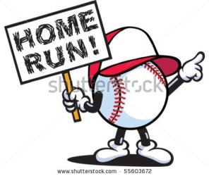

A: I want to go to the ball game.
B: Is there a game tonight?
A: Yes, it starts at 7 p.m.
B: Can we get tickets?
A: Yes, but only the cheap tickets.
B: How much are they?
A: They’re only $5 each.
B: That’s a good price.
A: Yes, it’s cheaper than a hot dog or a beer.
B: Where are the seats?
A: They’re behind the outfield.
B: Maybe we can catch a home run ball.

LISTEN!
http://www.eslfast.com/easydialogs/ec/sports10.htm

