TEACHER : LEIDE DIAS SUBJECT: ENGLISH
STAGE: 8TH

CONTENTS:
DIALOGUE
TEXT
SIMPLE PRESENT: DO / DOES (AFFIRMATIVE, NEGATIVE AND INTERROGATIVE FORM)
SIMPLE PAST : DID
VERB CAN

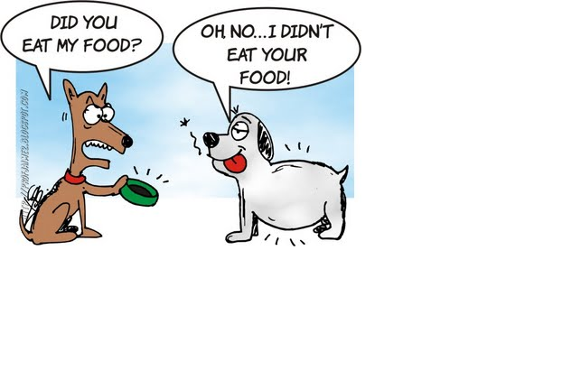
SIMPLE PAST

Example: to walk, simple past.

Affirmative | Negative | Interrogative
I walked | I didn't walk | Did I walk?
You walked | You didn't walk | Did you walk?
He,she,it walked | He didn't walk | Did he walk?
We walked | We didn't walk | Did we walk?
You walked | You didn't walk | Did you walk?
They walked | They didn't walk | Did they walk?

AFFIRMATIVE STATEMENTS (FRASES AFIRMATIVAS)
sujeito + verbo no Simple Past + complemento

Exemplos:

They played a song for Cabiria. (Eles tocaram uma canção para Cabíria.)

NEGATIVE STATEMENTS (FRASES NEGATIVAS)
sujeito + did + not (ou didn't, na forma contraída) + verbo principal na forma básica + complemento

Exemplos:

The cat didn't like the new cushion. (O gato não gostou da nova almofada.)

INTERROGATIVE STATEMENTS (PERGUNTAS)
did + sujeito + verbo principal na forma básica +complemento

Exemplos:

When did you come back? (Quando você voltou?)

REGULAR VERBS - EXCEPTIONS:

1) In verbs ending in –Y that have a consonant before, we cut the –Y and substitute it by –IED: Study = Studied (different from play, that has a vowel before = played)

2) In verbs ending in –E, we just add –D: danced

3) In verbs with one syllable ending in consonant + vowel + consonant,double the last consonant: stopped

4) In verbs with more than one syllable ending in vowel + consonant that have the last syllable strong (tônica), we double the last consonant: permitted

Can – verbo poder
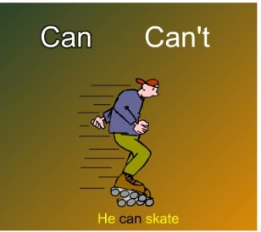

AFFIRMATIVE | NEGATIVE | INTERROGATIVE
I CAN | I CAN’T | CAN I?
YOU CAN | YOU CAN’T | CAN YOU?
HE CAN | HE CAN’T | CAN HE?
SHE CAN | SHE CAN’T | CAN SHE?
IT CAN | IT CAN’T | CAN IT?
WE CAN | WE CAN’T | CAN WE?
YOU CAN | YOU CAN’T | CAN YOU?
THEY CAN | THEY CAN’T | CAN THEY?
Examples:
- I can ride a horse. ability
- We can stay with my brother when we are in Paris. opportunity
- She cannot stay out after 10 PM. permission
- Can you hand me the stapler? request
- Any child can grow up to be president. possibility

QUESTIONS

A:What is your name?
B:………………………………………..
A: How old are you?
B:………………………………………………….
A: What is your favorite color?
B: ……………………………………………………….
A:What is your favorite food?
B: …………………………………………………………………..
A: What does your father like?
……………………………………………………………………………………………………………………….

