TEACHER : LEIDE DIAS SUBJECT: ENGLISH
STAGE: 7TH

CONTENTS
TEXT
SIMPLE PRESENT: DO / DOES (AFFIRMATIVE, NEGATIVE AND INTERROGATIVE FORM)
PRESENT CONTINUOUS
SIMPLE PRESENT:DO/ DOES

VERB TO WORK
Positive | Negative | Interrogative
I work | I don’t work | Do I work?
You work | You don’t work | Do you work?
He works | He doesn’t work | Does he work?
She works | She doesn’t work | Does she work?
It works | It doesn’t work | Does it work?
We work | We don’t work | Do we work?
You work | You don’t work | Do you work?
They work | They don’t work | Do they work?

Simple present - Uso
O Present simple é usado para contar fatos, ações que acontece no presente e fatos permanentes
Exemplos:
She plays the guitar with friends - Ela toca violão com os amigos.
I clean up the house every day - Eu limpo a casa todos os dias.
I go to supermarket to buy food. Vou ao supermercado comprar comida.
 | To speak | To go | To brush | To study | To play
I | speak | go | brush | study | play
You | speak | go | brush | study | play
He / She | speaks | goes | brushes | studies | plays
It | speaks | goes | brushes | studies | plays
We | speak | go | brush | study | play
You | speak | go | brush | study | play
They | speak | go | brush | study | play

Can – verbo poder
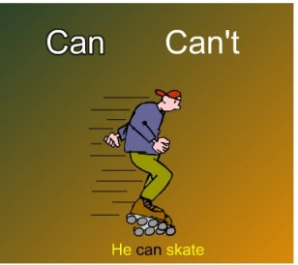

AFFIRMATIVE | NEGATIVE | INTERROGATIVE
I CAN | I CAN’T | CAN I?
YOU CAN | YOU CAN’T | CAN YOU?
HE CAN | HE CAN’T | CAN HE?
SHE CAN | SHE CAN’T | CAN SHE?
IT CAN | IT CAN’T | CAN IT?
WE CAN | WE CAN’T | CAN WE?
YOU CAN | YOU CAN’T | CAN YOU?
THEY CAN | THEY CAN’T | CAN THEY?
Examples:
- I can ride a horse. ability
- We can stay with my brother when we are in Paris. opportunity
- She cannot stay out after 10 PM. permission
- Can you hand me the stapler? request
- Any child can grow up to be president. possibility

PRESENT CONTINUOUS
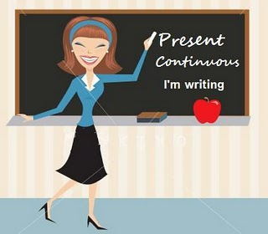
A. Structure
Negative
I am not singing / I'm not singing
You are not singing / You aren't singing / You're not singing
He is not singing / He isn't singing / He's not singing
She is not singing / She isn't singing / She's not singing
It is not singing / It isn't singing / It's not singing
We are not singing / We aren't singing / We're not singing
You are not singing / You aren't singing / You're not singing

Affirmative
I am singing / I'm singing
You are singing / You're singing
He is singing / He's singing
She is singing / She's singing
It is singing / It's singing
We are singing / We're singing
You are singing / You're singing
They are singing / They're singing
They are not singing / They aren't singing / They're not singing
Interrogative
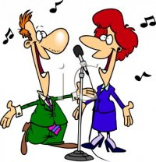
Am I singing?
Are you singing?
Is he singing?
Is she singing?
Is it singing?
Are we singing?
Are you singing?
Are they singing?

