TEACHER : LEIDE DIAS SUBJECT: ENGLISH
STAGE: 6TH

CONTENTS:
DIALOGUE
TEXT
VERB TO BE (AFFIRMATIVE, NEGATIVE AND INTERROGATIVE FORM)
VERB TO HAVE (HAS/HAVE)
VERB CAN

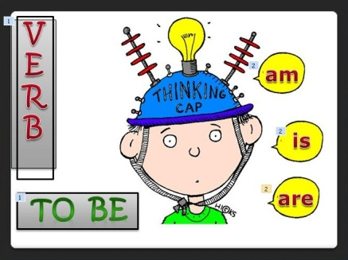
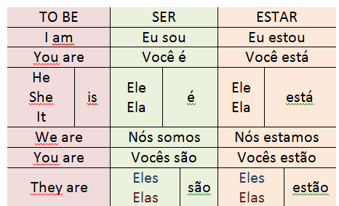
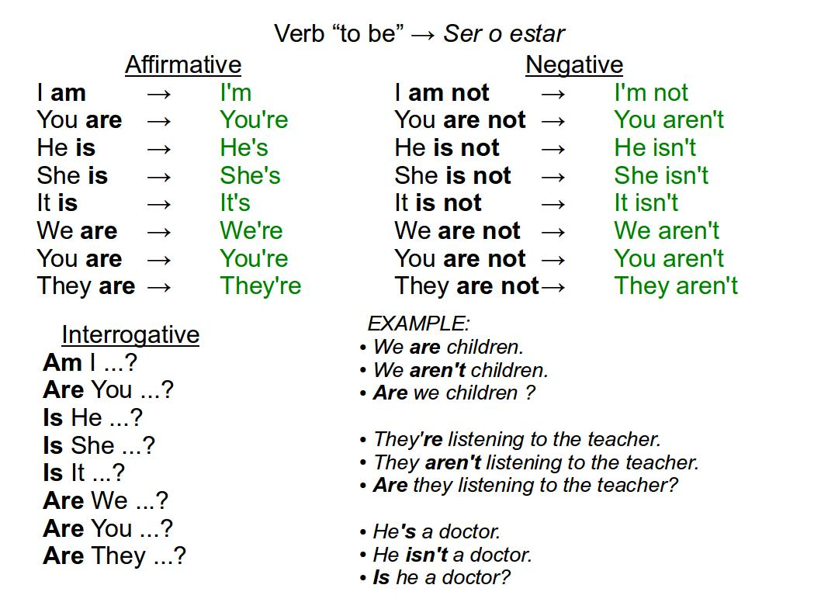

Can – verbo poder
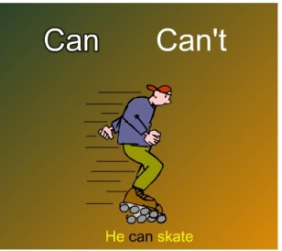

AFFIRMATIVE | NEGATIVE | INTERROGATIVE
I CAN | I CAN’T | CAN I?
YOU CAN | YOU CAN’T | CAN YOU?
HE CAN | HE CAN’T | CAN HE?
SHE CAN | SHE CAN’T | CAN SHE?
IT CAN | IT CAN’T | CAN IT?
WE CAN | WE CAN’T | CAN WE?
YOU CAN | YOU CAN’T | CAN YOU?
THEY CAN | THEY CAN’T | CAN THEY?
Examples:
- I can ride a horse. ability
- We can stay with my brother when we are in Paris. opportunity
- She cannot stay out after 10 PM. permission
- Can you hand me the stapler? request
- Any child can grow up to be president. possibility

HAVE / HAS
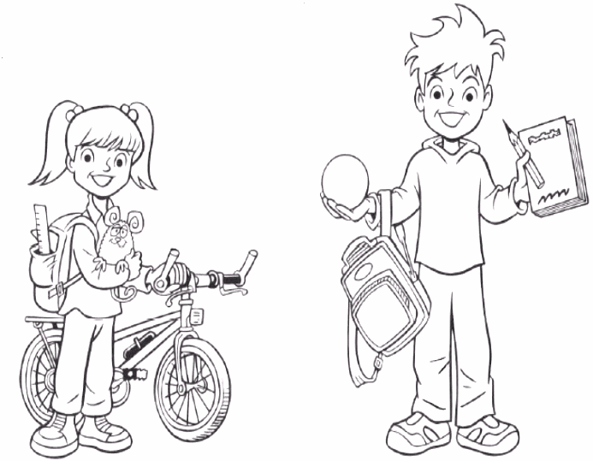

I HAVE (eu tenho)
YOU HAVE (você tem)
HE HAS(ele tem)
SHE HAS(ela tem)
IT HAS(ele/ela tem)
WE HAVE(nós temos)
YOU HAVE (vocês têm)
THEY HAVE (eles têm)
- Look at the picture and complete the sentences: have or has
- Meet Ben and Penny. They brother and sister.
  - She long hair and her brother short hair.
  - Penny a new bicycle. She a small toy mouse .
  - Ben a book and a pencil in his hand. He also a ball.
  - They school bags today.

QUESTIONS:
A:What is your name?
B:………………………………………..
A: How old are you?
B:………………………………………………….
A: What is your favorite color?
B: ……………………………………………………….
A:What is your favorite food?
B: …………………………………………………………………..
A: What does your father like?

