TEACHER : LEIDE DIAS SUBJECT: ENGLISH
STAGE: 1st – Ensino Médio

CONTENTS:
DIALOGUE
TEXT
SIMPLE PRESENT: DO / DOES
AFFIRMATIVE, NEGATIVE AND INTERROGATIVE STATEMENTS
THE THIRD PERSON: -S, -ES,-IES.

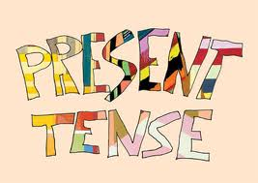

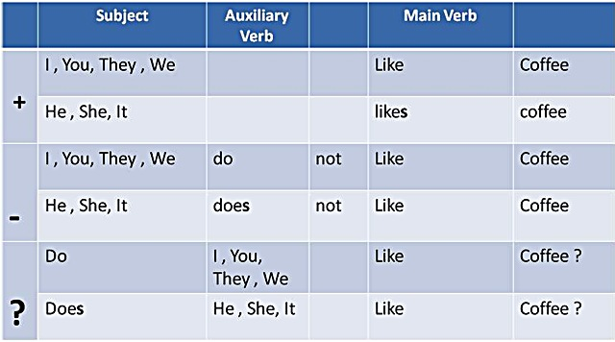

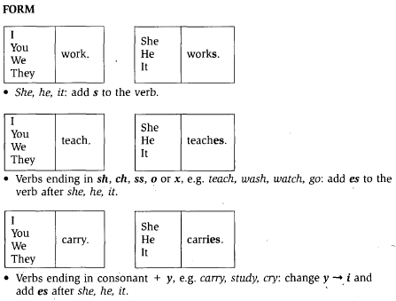
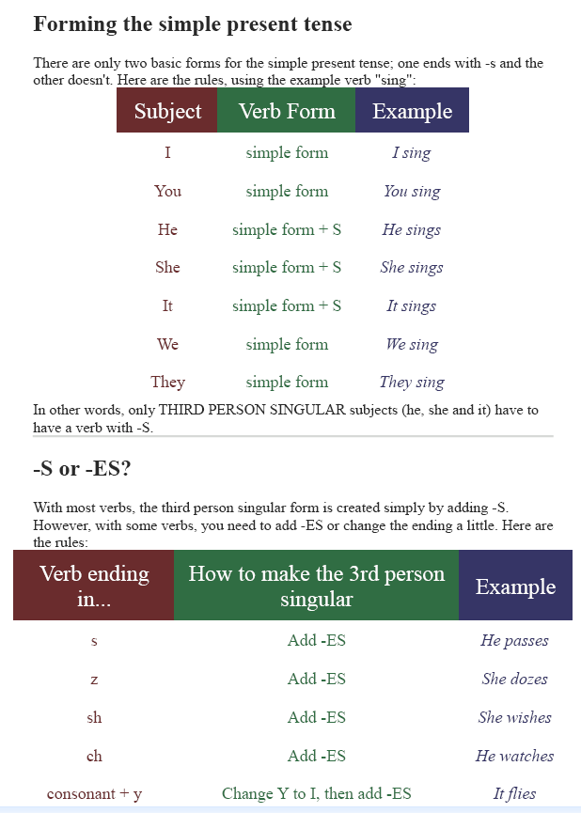

VERB TO WORK
Positive | Negative | Interrogative
I work | I don’t work | Do I work?
You work | You don’t work | Do you work?
He works | He doesn’t work | Does he work?
She works | She doesn’t work | Does she work?
It works | It doesn’t work | Does it work?
We work | We don’t work | Do we work?
You work | You don’t work | Do you work?
They work | They don’t work | Do they work?

Affirmative form:
Para as primeiras e segundas pessoas, o verbo fica igual à forma infinitiva (mas sem a partícula “to”), nas terceiras pessoas, há a necessidade de adicionar ao fim do verbo as extensões “s“, “es” ou “ies“.
Exemplos:
- He washes the car (ele lava o carro)
- I like internet (eu gosto de internet)
Interrogative form:
Para fazer frases interrogativas, vamos usar o auxiliar DO (ou DOES, para as terceiras pessoas) antes do verbo. Exemplos:
- Do you go to school ? (Você vai para a escola ?)
- Does she work ? (Ela trabalha? )
Negative form:
Para tornar uma frase negativa, é só adicionar o “NOT” depois do DO ou DOES:
- I Do not (don’t) work (eu não trabalho)
- She does not (doesn’t) work (ela não trabalha)

QUESTIONS
A:What is your name?
B:………………………………………..
A: How old are you?
B:………………………………………………….
A: What is your favorite color?
B: ……………………………………………………….
A:What is your favorite food?
B: …………………………………………………………………..
A: What does your father like?
……………………………………………………………………………………………………………………….

